**Name:** Christine Jade P. Ondis & Magdaline Infante **Subject:** Data Structures and Algorithms

**Course, Year& Section:** BSIS-2A **Professor:** Ma’am Kristine Botin

**Sorting Heroes in a Superhero Mission Control**

**Theme**: *"*Managing Superheroes in Mission Control*"*. Superheroes have different power levels and you need to prioritize them for missions using heaps.

**Participants should:**

1. Learn how to insert and delete elements in Max-Heaps and Min-Heaps.
2. Implement the Heapify operation on an array.
3. Convert a random array into a valid heap.

**Task 1: Insert Superheroes into a Max-Heap**

* **Objective:** Insert superheroes into a Max-Heap one by one and print the heap after each insertion.
* **Example Input:**  
  Superheroes: {("Iron Man", 85), ("Captain Marvel", 95), ("Black Panther", 80)}
* **Output:**  
  After each insertion, display the heap:

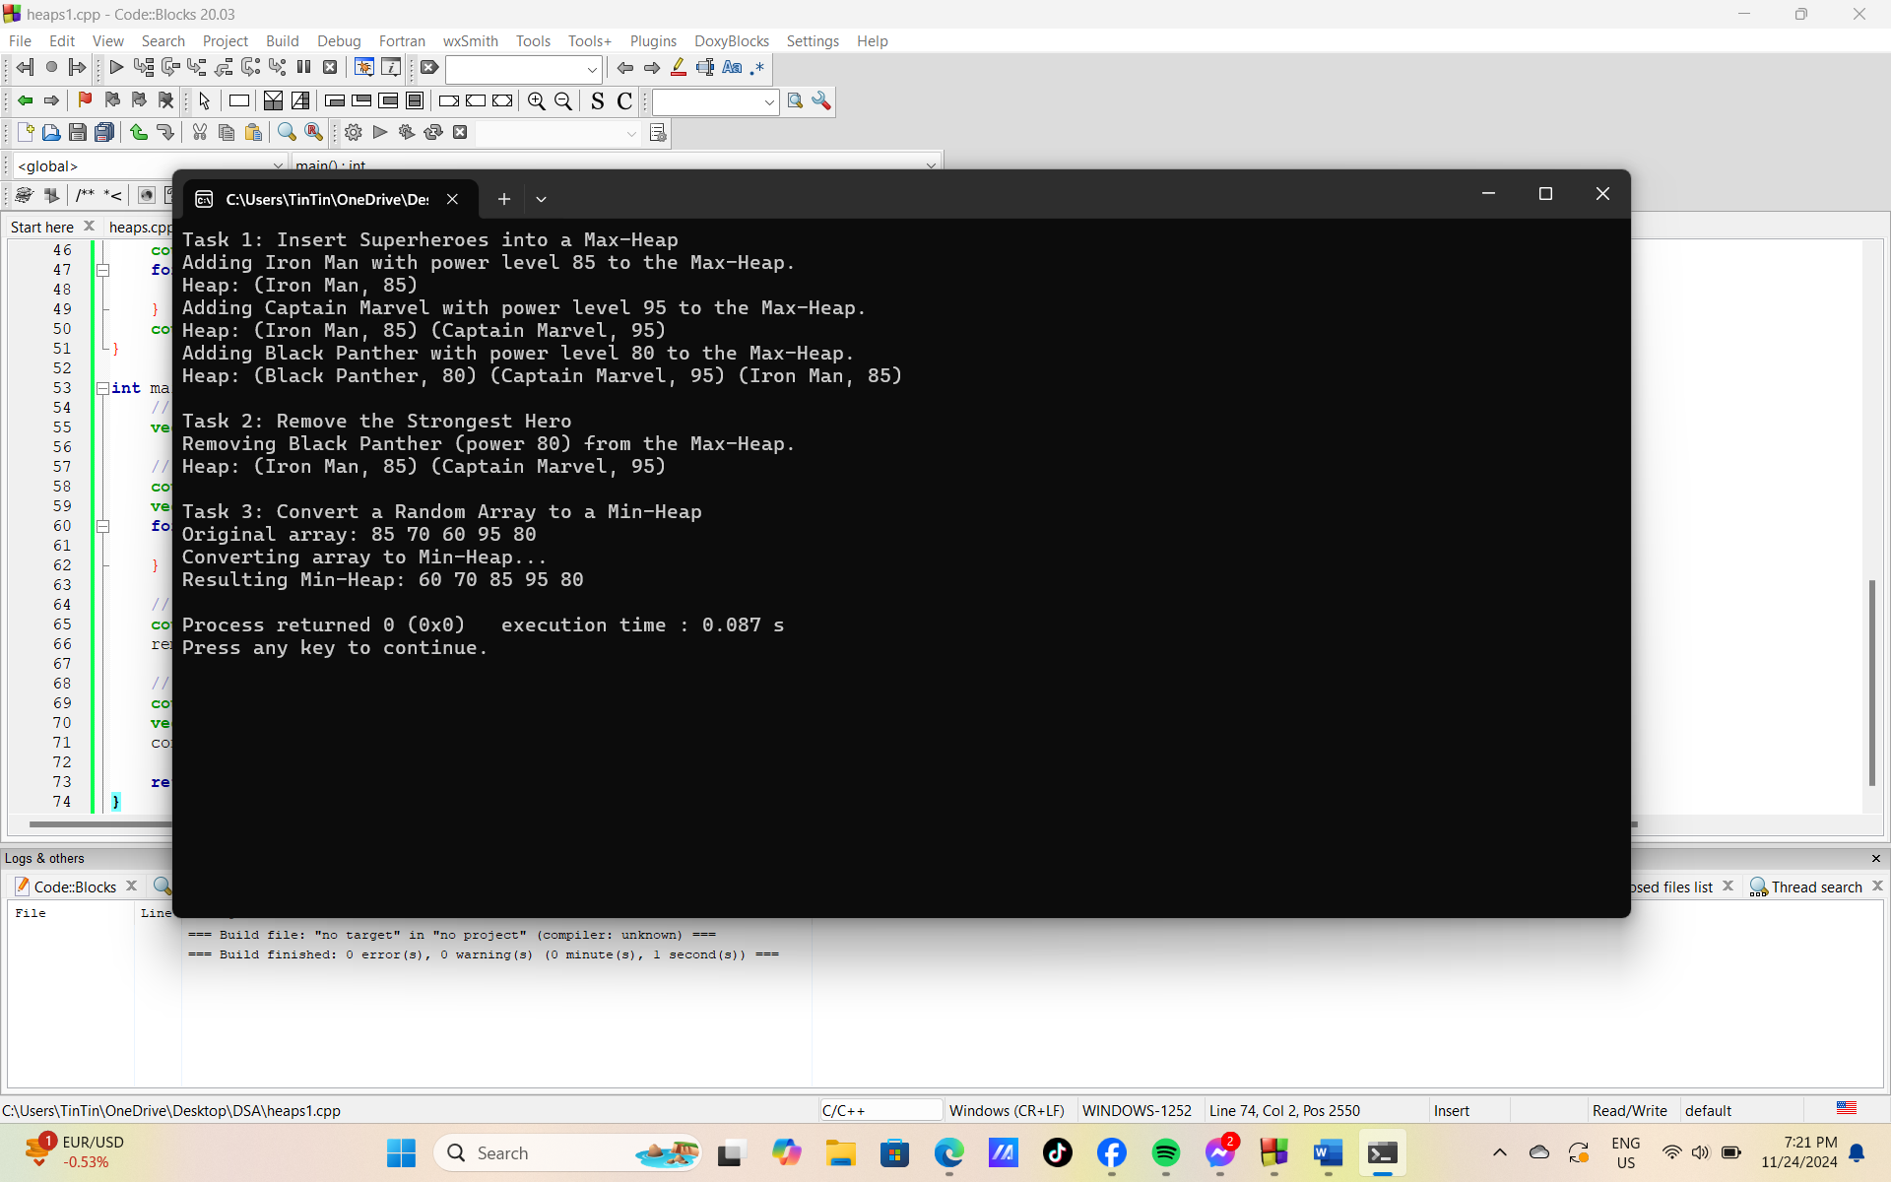

**Task 2: Remove the Strongest Hero**

* **Objective:** Remove the root (strongest hero) from the Max-Heap and restore the heap property.
* **Example Input:**  
  Current Heap: [95, 85, 80, 70, 60]
* **Output:**



**Task 3: Convert a Random Array to a Min-Heap**

* **Objective:** Transform a random array of superhero power levels into a Min-Heap.
* **Example Input:**  
  Power levels: [85, 70, 60, 95, 80]
* **Output:**



**Complete code:**

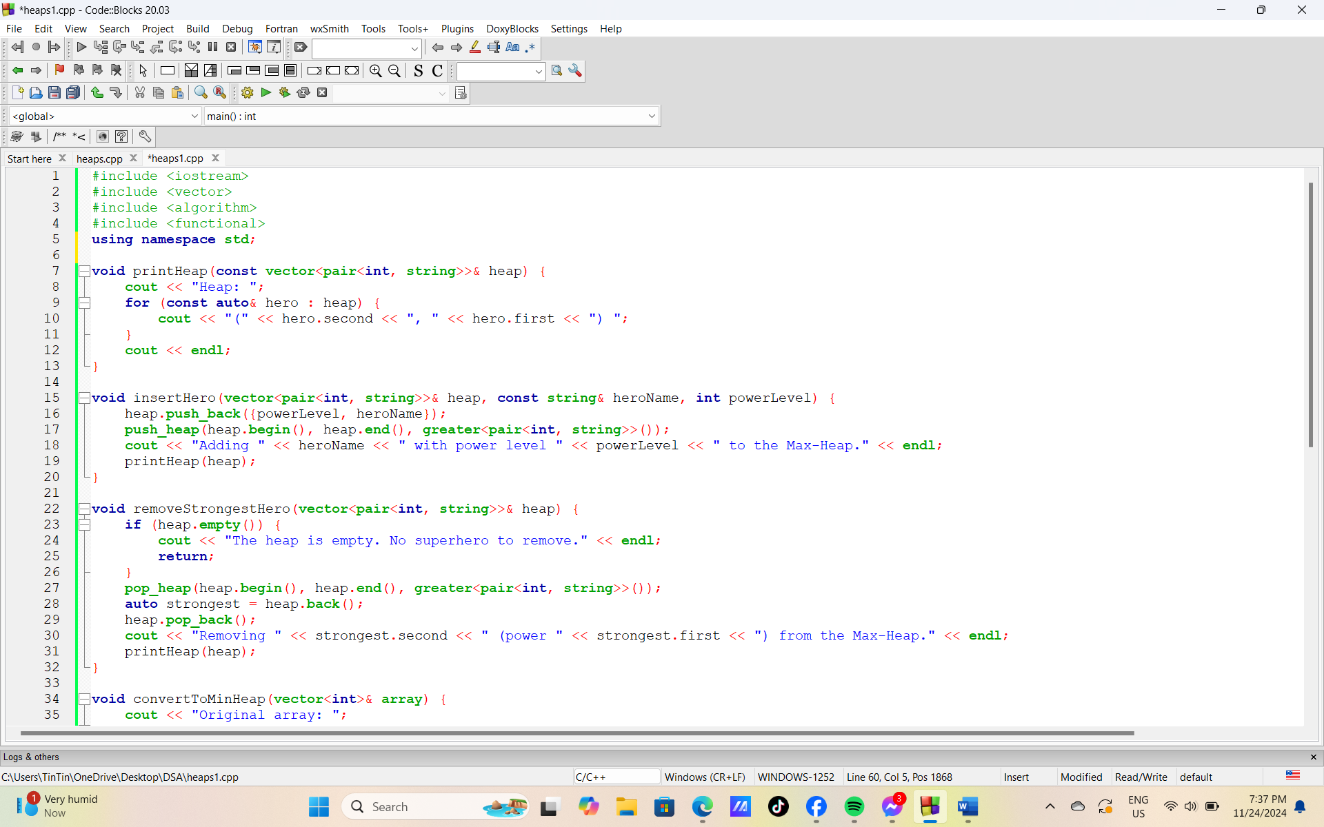

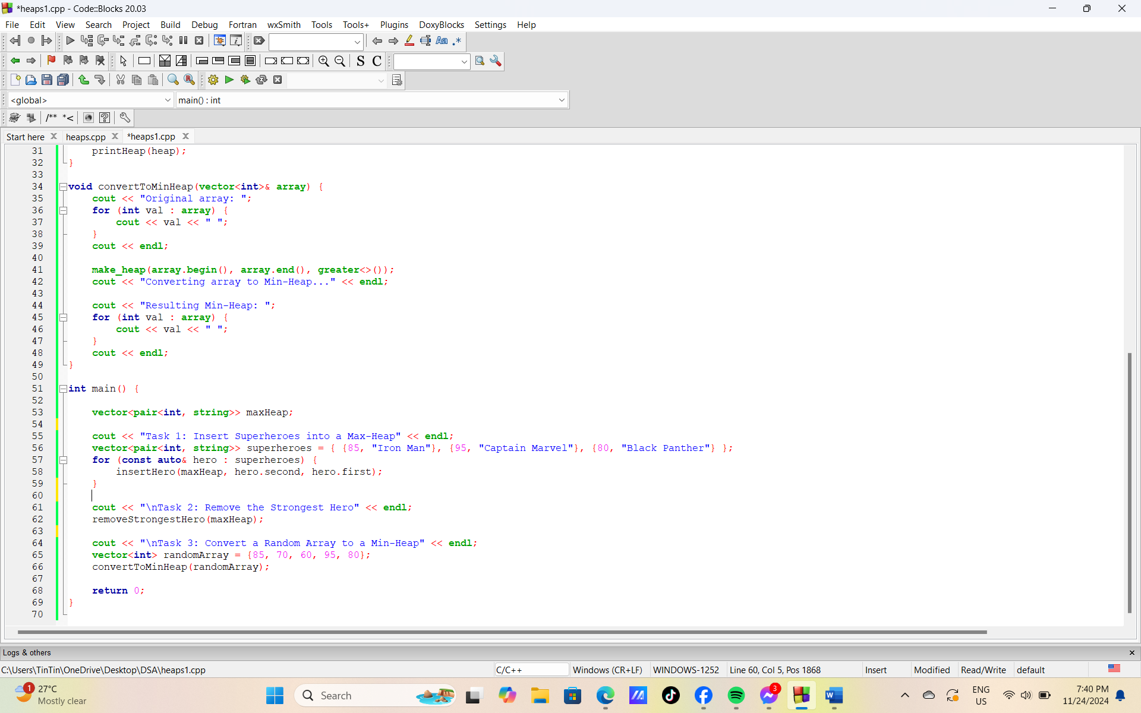

**Output:**

